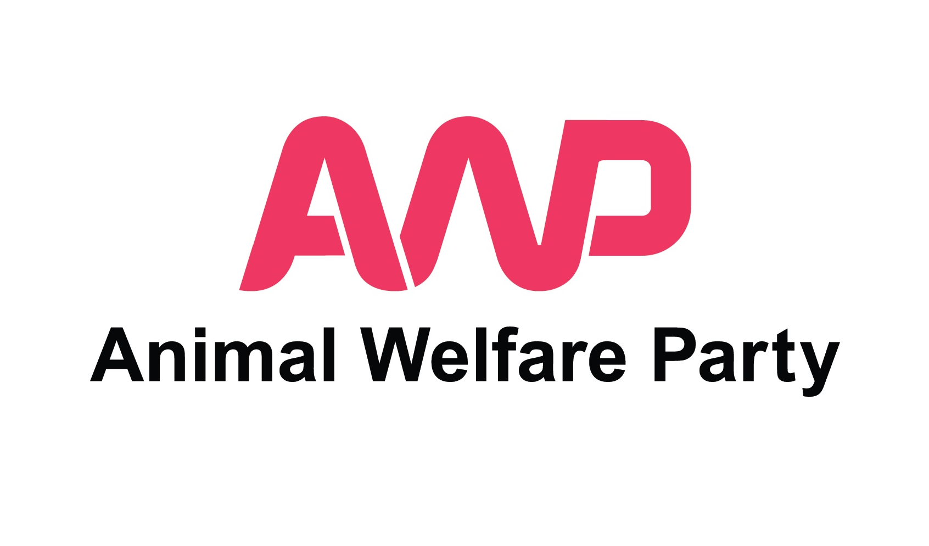
Prospective AWP Candidates
General Election taking place 22 - 25
Expression of Interest Form

Background

The next UK General Election will take place between 2022 and January 2025.

Since we do not know when a General Election may take place in this period, this form is for those Members who would like to express interest in being candidates in an election that could take place at any time during the period mentioned above.

Whilst our manifesto for the next General Election is not yet published, our manifesto for the last General Election (2019) can be viewed at the link below:

https://www.animalwelfareparty.org/wordpress/wp-content/uploads/2019/12/Animal-Welfare-Party-2019-General-Election-Manifesto.pdf

Expression of Interest

As with all political parties, AWP candidates must take part in a selection process.

Only Full Adult Members of Animal Welfare Party are eligible to be candidates for the party in this election (Non Members, Associate Members and Young Members are not eligible to stand as candidates for the party in this election).

We welcome applications from people who live vegan or vegetarian lifestyles.

If you are a Full Adult Member of Animal Welfare Party and would like to express your interest in becoming an AWP candidate in a General Election taking place 2022 - January 2025, please download / save, read and fill out this form electronically with your answers. Please answer in another colour.

We advise reading the whole form through before starting to write your responses to the questions, paying particular attention to the questions which ask you about your eligibility to stand for election.

To apply, please return the following items to this email address: membership@animalwelfareparty.org

1. This completed form - saved with your name in the title
2. Your CV
3. A link to your supporting video within the body of your email as detailed below. Please don't attach a video file to your email.
4. In the subject field of your email please include '2022-25 General Election PC' followed by your first name and surname.

Deadline: There is currently no deadline set for applications. This will be updated in due course.

Candidates for Animal Welfare Party have a tough but important job to do, often speaking up for those who cannot speak for themselves to an audience who may not be familiar with giving time and thought to animal welfare / rights issues. We believe our candidates need to speak for animals and the environment as effectively as possible, being thorough, professional, patient and creative.

If you are interested in becoming a candidate for AWP we kindly ask you to fill out the form below. We will use your answers to assess your suitability to stand as a candidate in this particular election.

We are a volunteer-run organisation with extremely limited resources. Please note that, at this time, we are looking to select only those candidates who we feel are ready to stand for election now with very little development by the party.

If, from the answers you have provided here, we feel there is a strong match between the skills and experiences required and those you can currently offer, the next stage of the process will be to take part in a zoom interview with one or more of our Committee of National Officers.

If, on this occasion, your expression of interest is not taken further, this does not mean that you should not express interest again for future elections. Your suitability may change according to the particular election being held, the local knowledge required and as the skills, knowledge and experiences you develop over time. It is also AWP's ambition to have resources available to develop candidates for future elections.

Questions

Basic information and eligibility to stand in a General Election.

To be able to stand as a candidate at a UK Parliamentary general election in Great Britain you must, on the day you are nominated and on polling day, be:

• at least 18 years old, and
• either a British citizen, a citizen of the Republic of Ireland or an eligible Commonwealth citizen

Citizens of other countries (including EU member states other than the UK, Republic of Ireland, Cyprus and Malta) are not eligible to become a Member of the UK Parliament.

There is no requirement in law for you to be a registered elector in the UK.

We advise consulting the following guidance from the Electoral Commission in answering the questions below:

https://www.electoralcommission.org.uk/sites/default/files/2019-07/UKPGE-Part-1-Can-you-stand-for-election.pdf

1. Your full name:

2. Are you over 18?:

3. Are you on an electoral register in the UK?:

4. Your full address including postcode (where you are on the electoral register):

5. Nationality:

6. Which UK Parliamentary constituency do you live in (if applicable)?:

7. Having visited the link below and read the document, are you eligible to stand for election in these elections?:
https://www.electoralcommission.org.uk/sites/default/files/2019-07/UKPGE-Part-1-Can-you-stand-for-election.pdf

8. Are there any periods where you will be out of the country for more than a month during now and January 2025?

An example schedule is included at the end of this document to help gauge the involvement required once a date for the General Election is known.

About You:

9. How long have you been a member of AWP (Associate Members and Non Members may not stand as candidates for AWP)?:

10. Have you been an active member of any other party previously?:

11. Have you stood for election before? If yes, please give details:

12. Why would you like to stand as a candidate for AWP in this election?:

13. Which five of AWP's policies do you have most affinity with?:

14. Are there any of AWP's policies you feel less comfortable with?:

15. In a UK General Election, we will expect our candidates to promote plant-based diets for the benefit of the planet, animals and human health. How would this expectation chime with your own current lifestyle?

16. All candidates for Animal Welfare Party will be expected to campaign following the direction of an AWP Election Manager and to promote only those policies agreed by the party. Are you content to work in this way?

17. Exploring potential constituencies to stand in:
Please aim to detail at least three constituencies that you might conceivably stand for election in and provide a summary of each constituency including the details and brief analysis below. Please only include constituencies that you could reasonably travel to, to campaign, leaflet and attend events in. Please don't include constituencies that would be too far away for you to travel to and campaign in. Unfortunately, the party is unlikely to be able to fund travel expenses associated with campaigning in a constituency. If there aren't three constituencies that you could reasonably campaign in, please let us know with a brief explanation.

For each potential constituency tell us about:

-The name of the constituency

-The current (sitting) MP and party they represent

-What majority the seat is held with

-Whether the seat is being targeted as a potential 'gain' by another party or alliance

-What bearing AWP standing a candidate in this constituency might have on the final result of the election there

-What animal and environmental issues there may be in the constituency

-Whether you live or work in this constituency

-Whether you are 'known' to constituents in this constituency

-If neither of the above, how far away it is in time or distance from your work or home

-Please include any other details about the constituency that you feel would be useful for us to know at this stage

18. The deposit to stand in one constituency in a UK general election is £500. If selected as a candidate, we may need to explore with you various ways of raising the £500 fee. This may include fundraising exercises spearheaded by you. Are you open to this?

19. As a small party, AWP is unlikely to have the funds to match the election campaign activities of larger parties (party political broadcasts, multiple mailings, posters and banners). With that in mind, would you be comfortable being part of a very low budget election campaign?

20. How comfortable would you be in the following scenarios on a scale of 1 to 10 (where 1 indicates 'not at all comfortable' and 10 indicates 'extremely comfortable')?:

A) Knocking on doors in your local area (with a party colleague), introducing yourself and discussing AWP policy:

B) Standing in your local high street handing out your own election leaflets:

C) Attending a public event along with other candidates where you are required to answer questions from the public, describing what AWP's policies / stances / solutions would be to their issues:

D) Being interviewed by print / online journalists:

E) Being interviewed by radio journalists:

F) Being interviewed for TV or online video:

G) Recording a short video 'piece to camera' about your candidacy (for social media or our website):

21. Please tell us about any recent experience of work / voluntary work / campaigning within your local community:

22. Please tell us about anything else you feel may relevant to our understanding of your current suitability for the role:

23. Applicants must record a short video piece 'to camera' (maximum two minutes) in which you briefly introduce yourself and outline why you'd like to stand as a candidate for Animal Welfare Party in a General Election. We anticipate this will be recorded using a mobile phone, computer or similar. Please choose a quiet location with little background noise so that your voice can be heard clearly.

Please send the video file to us in one of the following ways:
- As a download link via wetransfer.com
- As a link to a private video on vimeo (please make sure the settings are set to ‘private’)
- As a link to a private video on youtube (please make sure the settings are set to ‘private’)

Please don't email your video as an attachment as large files may be rejected and / or not viewable by our team.

If you aren't able to complete this step please let us know with a brief explanation.

Your time in filling out this form is greatly appreciated.

Many Thanks

The AWP Team

AWP Example General Election Schedule (based on poll taking place 25th Oct.)

Sept 5th - Invitations to interview (remote) sent by this date (if not already conducted).

Sept 14th / 15th / 16th - Prospective candidate interviews (remote) (if not already conducted).

Sept 19th - Notification of selected candidates by email.

Successful applicants:

Sept 20th - AWP Data Protection Training Document to be issued to all candidates and read before next stage of process.

Sept 24th - Signed authorisation papers (to use the AWP name and emblem) to be sent from AWP's Nominating Officer to candidates' home addresses.

By Sept 26th - Candidates request electoral register from local election office (these are needed to complete nomination papers). (Those receiving this data must have received and completed the AWP Data Protection training).

By Oct 3rd - Candidates complete nomination papers – inc. obtaining signatures from local electors on electoral register (these must be checked against the electoral register to avoid nomination papers being rejected).
Signatures of 10 registered electors (known as subscribers) from the constituency are needed. The subscribers must appear on the local government electoral register that is in force on the 25th working day before the poll.

By Oct 4th - Candidates deliver nomination and authorisation papers to local election office (papers must be delivered by hand by candidate, agent or trusted person). Deadline for delivery TBC.

Oct 4th - Candidate list published.

By Oct 4th - Candidates have professional headshot photographs taken in local setting in smart attire (for use in leaflets and other marketing material such as social media posts). Candidates will need to refer to notes supplied on photography which will include notes on framing, background and attire. Photos must immediately be sent to AWP for leaflet design.

Oct 5th and 6th - Leaflet design done centrally for all candidates (2 side A5 design).

Oct 7th - Leaflets ordered centrally (quantities depending on funds).

Oct 11th - Leaflets delivered to candidates home or work addresses (for personal distribution).

Oct 11th and 14th - Leaflets delivered to Royal Mail delivery offices for Royal Mail delivery (quantities depending on funds).

Oct 12th onwards - Leafleting sessions in constituency / campaigning / leaflet distribution (please always leaflet in pairs for safety reasons).

Oct 25th Poll (and end date of regulated period).

TBC – Submit spending returns and declarations (agents and candidates).

Data Protection & Privacy:

We promise to treat your personal details with care and we will never sell them. The information you provide will be used for candidate assessment, candidate election management and administration.
Please read our full privacy policy for more information (available at: www.animalwefareparty.org/about/privacy).

