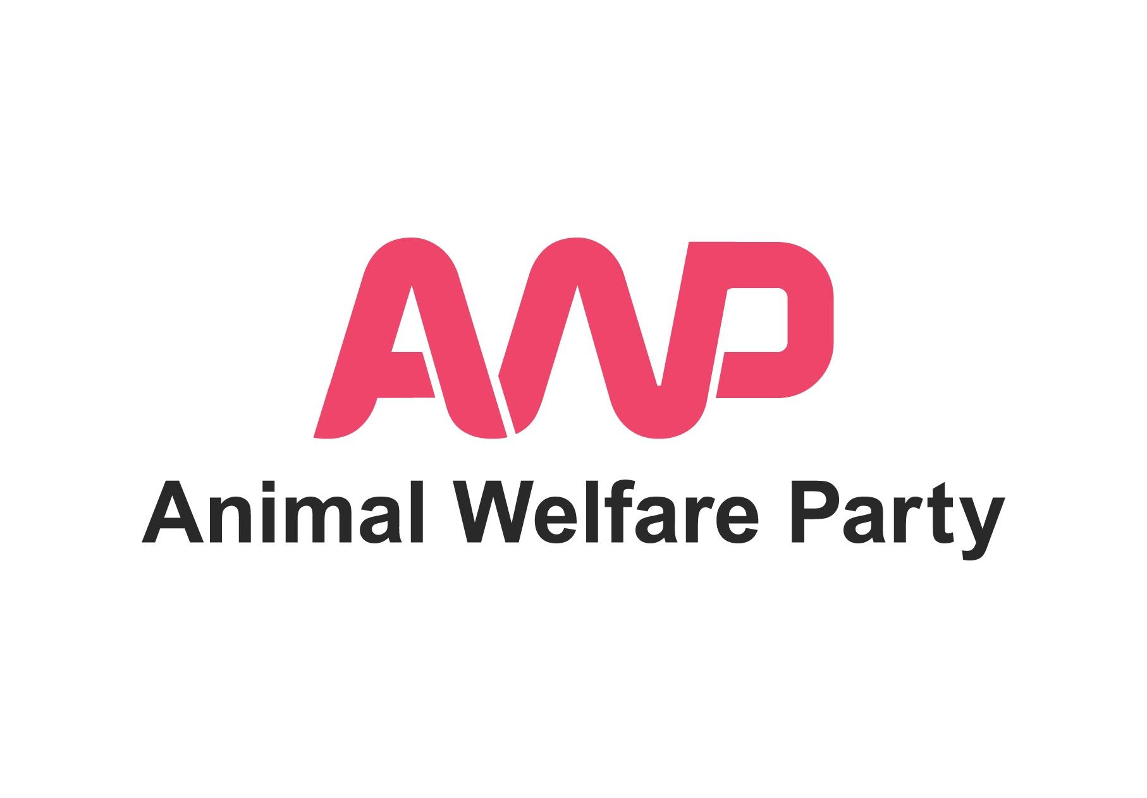

**2022 Local Elections**

**Prospective AWP Candidates Expression of Interest Form**

**Background**

Local Elections take place on 5th May 2022. These include elections for the Northern Ireland Assembly, all local authorities in Wales and Scotland and, in England, elections for all London borough councils, certain county councils, metropolitan boroughs, district councils, unitary authorities, six local authority mayors and one metropolitan mayor.

To find out if there are elections happening where you live or work, please visit the link below and enter your postcode:

www.electoralcommission.org.uk/who-we-are-and-what-we-do/elections-and-referendums/upcoming-elections

If there are elections happening near you and you’re interested in standing as a candidate for Animal Welfare Party in these elections please read through and complete this form.

We welcome applications from all suitably-qualified candidates, irrespective of gender, disability, racial, ethnic or social origin, colour, religion, belief, or sexual orientation. There is no upper age limit.

If you missed our recent webinar on ‘Standing as an AWP Candidate in Local Elections 2022’ you can view a recording here:

<https://youtu.be/dWDVln8V6FY>

**Expression of Interest**

As with all political parties, AWP candidates must take part in a selection process.

Only Full Adult Members of Animal Welfare Party are eligible to be candidates for the party in this election (Non Members, Associate Members and Young Members are not eligible to stand as candidates for the party in this election).

If you are a Full Adult Member of Animal Welfare Party and would like to express your interest in becoming an AWP candidate in the 2022 elections, please read and fill out this form electronically with your answers. Please answer in another colour.

We advise reading the whole form through before starting to write your responses to the questions, paying particular attention to questions 10 and 12 which ask you about your eligibility to stand for election and your availability.

We use reference information provided on the Electoral Commission website and Elections Office Northern Ireland website which we mention below. If you would like to review the available resources yourself, please visit:

[www.electoralcommission.org.uk/i-am-a/candidate-or-agent](http://www.electoralcommission.org.uk/i-am-a/candidate-or-agent)

<http://www.eoni.org.uk/Elections/Information-for-candidates-and-agents>

To apply, please return the following items to this email address:

**membership@animalwelfareparty.org**

1. This completed form
2. Your CV / Resume
3. A download link to your video, if supplying, in the body of your email. Please don't attach a video file to your email.
4. In the subject field of your email please include '2022 Local Elections' followed by your first name and surname.

**Deadline: Please send all your documents to us by midnight 23rd February 2022.**

**Data Protection & Privacy**

We promise to treat your personal details with care and we will never sell them. The information you provide will be used for candidate assessment, candidate election management and administration.

Please read our full privacy policy for more information (available at: www.animalwefareparty.org/about/privacy).

**How we will use your responses**

Candidates for Animal Welfare Party have a tough but important job to do, often speaking up for those who cannot speak for themselves to an audience who may not be familiar with giving time and thought to animal welfare / rights issues. We believe our candidates need to speak for animals and the environment as effectively as possible, being thorough, professional, patient and creative.

We will use the answers you provide below to assess your suitability to stand as a candidate in this particular election.

We are a volunteer-run organisation with extremely limited resources. Please note that, at this time, we are looking to select only those candidates who we feel are ready to stand for election now with very little development by the party.

If, from the answers you have provided here, we feel there is a strong match between the skills and experiences required and those you can currently offer, the next stage of the process will be to attend a zoom interview with AWP Committee members.

If, on this occasion, your expression of interest is not taken further, this does not mean that you should not express interest again for future elections. Your suitability may change according to the particular election being held, the local knowledge required and as the skills, knowledge and experiences you have developed over time. It is also AWP's ambition to have resources available to develop candidates for future elections.

**Questions**

**Basic information and Eligibility to stand in the 2022 Local Elections:**

1. Full name:

2. Are you over 18?:

3. Are you on an electoral register in the UK or Ireland?

4 a) Full address including postcode (where you are on the electoral register):

b) Preferred Email address and phone number for us to contact you:

5. What citizenship do you hold?

6. If you live in the UK, which Parliamentary constituency do you live in?

7. Which is your local authority?

8. In which local council ward do you live?

9. Are there elections taking place this year in your local area?

10. Please indicate the office you anticipate standing for election to / the election you anticipate standing in:

11. Please visit one of the links below and check you meet the eligibility criteria to stand for election:

Scottish Council Elections:

​​[www.electoralcommission.org.uk/sites/default/files/2021-11/SLG%20Part%201%20Can%20you%20stand%20for%20election.pdf](http://www.electoralcommission.org.uk/sites/default/files/2021-11/SLG%20Part%201%20Can%20you%20stand%20for%20election.pdf)

Welsh Local Elections:

[www.electoralcommission.org.uk/sites/default/files/2021-11/Part%201%20Can%20you%20stand%20for%20election%20LGW.pdf](http://www.electoralcommission.org.uk/sites/default/files/2021-11/Part%201%20Can%20you%20stand%20for%20election%20LGW.pdf)

England Local Elections:

[www.electoralcommission.org.uk/sites/default/files/2022-01/Part%201%20Can%20you%20stand%20for%20election%20LGE.pdf](http://www.electoralcommission.org.uk/sites/default/files/2022-01/Part%201%20Can%20you%20stand%20for%20election%20LGE.pdf)

Mayoral Elections in England:

[www.electoralcommission.org.uk/sites/default/files/2020-01/MAY%20-%20Part%201%20-%20Can%20you%20stand%20for%20election.pdf](http://www.electoralcommission.org.uk/sites/default/files/2020-01/MAY%20-%20Part%201%20-%20Can%20you%20stand%20for%20election.pdf)

Northern Ireland Assembly Elections:

<http://www.eoni.org.uk/Elections/Information-for-candidates-and-agents>

Having visited the relevant link above and read the document, are you eligible to stand for election in the election you intended?

12. Please read the AWP Draft Election Schedule at the end of this document. Are there any aspects of the AWP draft schedule that you could not meet because, for example, you will be away on holiday / working away / have a prior engagement?

**About You:**

13. How long have you been a member of AWP (Associate Members and Non Members may not stand as candidates for AWP)?

14. Have you been an active member of any other party previously?

15. Have you stood for election before? If yes, please give details:

16. Why would you like to stand as a candidate for AWP in this election?

17. In your opinion, what are the top five issues voters in your local area are concerned with?

18. How much interest do you feel there is in animal welfare / rights / sustainability issues in your local community and what do you base that assessment upon?

19. Which five of AWP's policies do you have most affinity with?

20. Are there any of AWP's policies you feel less comfortable with?

21. Are there any policies you feel AWP should give consideration to (at either local or national level)?

22. How comfortable would you be in the following scenarios on a scale of 1 to 10 (where 1 indicates 'not at all comfortable' and 10 indicates 'extremely comfortable')?:

A) Knocking on doors in your local area (with a party colleague), introducing yourself and discussing AWP policy:

B) Standing in your local high street handing out your own election leaflets:

C) Attending a public event along with other candidates where you are required to answer questions from the public, describing what AWP's policies / stances / solutions would be to their issues:

D) Being interviewed by print / online journalists:

E) Being interviewed by radio journalists:

F) Being interviewed for TV or online video:

G) Recording a short video 'piece to camera' about your candidacy (for social media or our website):

23. Please tell us about any recent experience of work / voluntary work / campaigning within your local community:

24. Please tell us about anything else you feel may relevant to our understanding of your current suitability for the role:

25: Candidates for AWP are expected to wear smart, business / business casual type attire when representing the party in person, in photos, in videos and in video meetings (except where the activity being undertaken requires a different type of dress). Please let us know if this presents any issues for you:

26: Candidates for AWP are expected to always communicate respectfully when representing the party, including with those whose opinions differ from our own. Please indicate that this something you feel you could agree to:

27: Candidates for AWP should not be under the influence of alcohol or drugs when representing the party. Please indicate if this is something you feel you can agree to:

28. Applicants are encouraged to record a short video piece 'to camera' (maximum two minutes) in which you briefly introduce yourself and outline why you’d like to stand as candidate for AWP in this area. We anticipate this will be recorded using a mobile phone / laptop / webcam or similar.

Once you've recorded your video, please aim to name the file with your own name so that we can easily identify it.

Please send it to us via a download link within your email. You can use the free website **wetransfer.com** to transfer the video to us. It will create a download link which can be pasted into the body of your email to us.

Please don't email your video as an attachment to the email as large files may be rejected.

If you can’t complete this step please provide a very brief explanation of the main reason (this will allow us to understand if / how we could help with video):

29. Please use this space to tell us anything else you think would be useful for us to know. You can also tell us about any concerns or questions you may have here:

Your time in filling out this form is greatly appreciated.

Many Thanks

The AWP Team

*Data Protection & Privacy:*

*We promise to treat your personal details with care and we will never sell them. The information you provide will be used for candidate assessment, candidate election management and administration.*

*Please read our full privacy policy for more information (available at: www.animalwefareparty.org/about/privacy).*

**AWP Draft Schedule - 2022 Local Elections**

**23rd Feb** - Deadline for receipt of Expressions of Interest

**5th & 6th March** -Interviews (remote) with prospective candidates

**12th & 13th March** -Interviews (remote) with prospective candidates

**16th March -** Notification of successful candidates by email

**17th March -** Successful candidates to make appointments to submit nominations paperwork in person to local elections office between 23rd March and 1st April (buffer needed in case of rejection of papers)

**c19th March -** Nominating Officers posts signed nomination papers to candidate home addresses

**17th March to 5th April -** Candidate photography - professional headshots need to be taken for use in leaflets / promotion / media requests. AWP can assist with finding a photographer and supply a photography guide.

1 minute candidate videos may also be shot - to be discussed with AWP

**23rd March** - Nomination Papers signed by Nominating Officer received by all candidates - please inform us if not received by this point.

**5 April 2022 at 4pm** - Close of Nominations - All nominations paperwork must be submitted and approved by this point.

**5th / 6th April -** Announcement of persons nominated - AWP will start to publicise candidates and policies - candidates can start to share AWP’s posts on twitter, fb, instagram.

**7/8/9/10/11 April -** Leaflets designed centrally by AWP (2 side A5)

**c12th April -** Designs sent to printers

**18th April -** Leaflets (500 to 1000) sent to candidates home addresses for personal distribution by candidates and supporters (first 1000 from AWP budget, any additional leaflets to be covered by candidate’s own fundraising efforts).

Please note, there is no free Royal Mail distribution of election leaflets for local elections. Any leaflets must be delivered by hand. Considerations around disposal.

Up to 5 posters (A3) may also be available if required.

**18th April - 5th May** Campaigning in local community or online (TBC / depending on covid rules) - may include debates, media interviews, community events.

**5 May 2022 7.00am until 10.00pm - Polling Day**

**6th / 7th May -** Results & wrap up

**6th May onwards -** Leaflet and poster disposal - rules apply to disposal

**June 10th TBC** - Election spending returns to be submitted