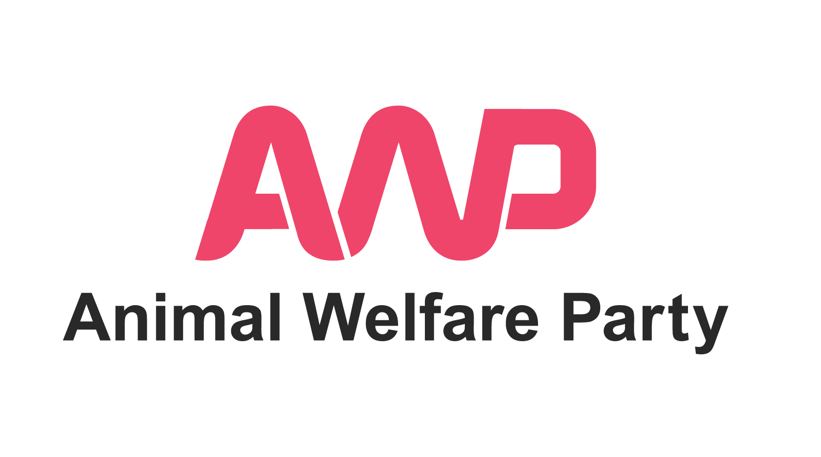
Animal Welfare Party
2020 London Wide Assembly Election
Potential Candidates Expression of Interest Form

Background

On 7th May, elections for the Mayor of London and London Assembly will take place.

Londoners who go to vote will be given 3 ballot papers:

Ballot paper 1 – to vote for the Mayor of London

Ballot paper 2 – to vote for London Assembly Constituency Member

Ballot paper 3 – to vote for London-wide Assembly Member

About the London Assembly:

The London Assembly is made up of 25 Members - 11 represent the whole capital and 14 are elected by London’s constituencies.
Members hold the Mayor to account by examining Mayoral strategies, decisions and actions to make sure they are in the public interest.
They champion Londoners’ concerns by investigating important issues and pressing for changes to national, Mayoral or local policy.
They also have the power to reject strategies and make changes to budgets when two-thirds of Assembly Members agree.
The Mayor is questioned by the Assembly 10 times a year at Mayor’s Question Time.

About the London-wide Assembly Election:

The London-wide Assembly election is held under a modified D'Hondt method of closed-list voting, a type of Proportional Representation.

To win a seat in the London-wide Assembly election 5% of votes are needed. To retain the £5000 deposit, 2.5% of votes are needed.

Animal Welfare Party last contested the London-wide Assembly Election in 2016 with a party list of 5 candidates. We received 25,810 votes (1%).

Here is a link to the policies AWP campaigned on in 2016:
https://www.animalwelfareparty.org/current-elections/2016-london-assembly-election-2

For 2020, our aim is to stand in both the London Mayoral election (signatures permitting) and the London-wide Assembly election.

In the London-wide Assembly election, it is possible for AWP to have a party list of up to 25 candidates and we intend to submit our nomination papers on 30th March.

This form is for AWP Members who meet the eligibility criteria outlined below and who are interested in expressing interest in being on AWP's Party List for the London-wide election.

Expression of Interest

As with all political parties, AWP candidates must take part in a selection process.

Only Full Adult Members of Animal Welfare Party are eligible to be candidates for the party in this election (Non Members, Associate Members and Young Members are not eligible to stand as candidates for the party in this election).

If you are a Full Adult Member of Animal Welfare Party and would like to express your interest in being on AWP's Party List for the London-wide Assembly Election, please read and fill out this form electronically with your answers. Please answer in another colour.

We advise reading the whole form through before starting to write your responses to the questions, paying particular attention to questions 1 – 12 which ask you about your eligibility to stand for election and your availability.

To apply, please return the following items to this email address: info@animalwelfareparty.org

- This completed form - saved with your name in the title as in the example below: Member_Firstname_Lastname_ExpressionOfInterest_LondonWideElection2020
- Your CV
- A link to your supporting video within the body of your email as detailed below. Please don't attach a video file to your email.
- In the subject field of your email please include 'Member_Firstname_Lastname_ExpressionOfInterest_LondonWideElection2020'

Deadline: Please send all your documents to us by Midnight on Sunday 15th March 2020.

Candidates for Animal Welfare Party have a tough but important job to do, often speaking up for those who cannot speak for themselves to an audience who may not be familiar with giving time and thought to animal welfare / rights issues. We believe our candidates need to speak for animals and the environment as effectively as possible, being thorough, professional, patient and creative.

If you are interested in becoming a candidate for AWP we kindly ask you to fill out the form below. We will use your answers to assess your suitability to stand as a candidate in this particular election.

We are a volunteer-run organisation with extremely limited resources. Please note that, at this time, we are looking to select only a candidate who we feel is ready to stand for election now with very little development by the party.

If, from the answers you have provided here, we feel there is a strong match between the skills and experiences required and those you can currently offer, the next stage of the process will be to attend an interview in London. Unfortunately, AWP does not have the financial resources to cover travel expenses.

If, on this occasion, your expression of interest is not taken further, this does not mean that you should not express interest again for future elections. Your suitability may change according the particular election being held, the local knowledge required and as the skills, knowledge and experiences you have develop over time. It is also AWP's ambition to have resources available to develop candidates for future elections.

Eligibility to stand in London Mayoral Election

Basic information and eligibility to stand as a candidate in the London-wide Assembly Election. Candidates must:

• be at least 18 years old on the day of nomination

• be a British citizen, an eligible Commonwealth citizen or a citizen of any other member state of the European Union

(An eligible Commonwealth citizen is a Commonwealth citizen who either:
• does not need leave to enter or remain in the United Kingdom, or
• has indefinite leave to remain in the United Kingdom)

and

• meet at least one of the following four qualifications:

a. You are, and will continue to be, registered as a local government elector in Greater London from the day of nomination onwards.

b. You have occupied as owner or tenant any land or other premises in Greater London during the whole of the 12 months before the day of nomination and the day of election.

c. Your main or only place of work during the 12 months prior to the day of nomination and the day of election has been in Greater London.

d. You have lived in Greater London during the whole of the 12 months before the day of your nomination and the day of election.

Disqualifications

Apart from meeting the qualifications for standing for election, you must also not be disqualified.

There are certain people who are disqualified from being elected as a Londonwide Assembly Member. You cannot be a candidate if at the time of your nomination and on the day of the election:

a. You are a member of staff of the GLA. For further information, see paragraph 1.21.

b. You hold an office or appointment designated by the Secretary of State as disqualifying you from being the Mayor of London or a Constituency or London-wide Member of the London Assembly. The Order listing the disqualifying offices
and appointments is The Greater London Authority(Disqualification) Order 2000 (as amended).

c. You are paid officer of a London borough council who is employed under the direction of that council’s executive (where executive arrangements are operating) or of committees or joint committees whose membership includes the Mayor of London. For further details, see paragraph 1.22.

d. You hold a politically restricted post in a” local authority” (defined). For further details, see paragraph 1.24.

e. You are the subject of a bankruptcy restrictions order or interim order. For more information, see paragraph 1.28.

f. You have been sentenced to a term of imprisonment of three months or more (including a suspended sentence), without the option of a fine, during the five years before polling day.

g. You have been disqualified under the Representation of the People Act 1983 (which covers corrupt or illegal electoral practices and offences relating to
donations). The disqualification for an illegal practice begins from the date a person has been reported guilty by an election court or convicted and lasts for three years. The disqualification for a corrupt practice begins from the date a person has been reported guilty by an election court or convicted and lasts for five years.

1.4 A person may also be disqualified from election if they have been disqualified from standing for election following a decision of the First-tier Tribunal (formerly the Adjudication Panel for England), or the Adjudication Panel for Wales.

We advise consulting the following guidance from the Electoral Commission (link below) before answering the questions below – the guidance document is named 'Can you stand for election'.

https://www.electoralcommission.org.uk/sites/default/files/2020-02/GLA%20Part%201%20-%20Can%20you%20stand%20for%20election.pdf

Questions

1. Full name:

2. Are you over 18?:

3. Are you on an electoral register in Greater London?

4. Full address including postcode (where you are on the electoral register):

5. If live in you live in a London borough please indicate which.

6. If you work in a London borough, please indicate which.

7. Nationality:

8. Do you have any plans to change address between now and 7th May 2020?

9. Having visited the link below and read the document, are you confident that you are eligible to stand for election in this election?:

https://www.electoralcommission.org.uk/sites/default/files/2020-02/GLA%20Part%201%20-%20Can%20you%20stand%20for%20election.pdf

10. Please read the AWP Draft Election Schedule at the end of this document. Are there any aspects of the AWP draft schedule that you could not meet because, for example, you will be away on holiday / working away / have a prior engagement?:

11. Please briefly indicate what your work / family / other obligations would be in the period from April 3rd to May 8th 2020.

12. Are there any periods during April 3rd to May 8th 2020 when you would be away and / or unable to take part in activities relating to being a candidate?

About You:

13. How long have you been a member of AWP (Associate Members and Non Members may not stand as candidates for AWP)?:

14. Have you been an active member of any other party previously?:

15. Have you stood for election before? If yes, please give details:

16. Please tell us about why you feel it important that Animal Welfare Party take part in the London-wide Assembly Election (please use as much space as you need).

17. Please tell us about why you would like to be a candidate on AWP's Party List in the London-wide election (please use as much space as you need).

18. Of Animal Welfare Party's 2016 policies for London, which do you feel most passionately about and why? (please use as much space as you need).

19. Are there any policies that you feel Animal Welfare Party should give consideration to for the 2020 London-wide election?

20. At our AWP Members' Meeting on 8th February, we discussed the idea of the AWP Mayoral and Assembly Candidates agreeing to sign up to between 5 and 10 common pledge points for the year ahead. The idea would be that the pledge points would show our candidates' commitment to 'walking the talk' when it comes to the climate and biodiversity crisis and animal exploitation and help to force the rate of change amongst other politicians / the public on these points. What are your thoughts on this approach?

21. Are there any 'pledge points' that you feel AWP candidates should give consideration to agreeing to for this year?

22. Which social media platforms do you use yourself and, if you were to become an AWP list candidate, would you be happy to promote your candidacy and associated activities via these channels?

23. With regard to the issues AWP is likely to campaign on how do you feel these will compare with the issues other candidates and parties are likely to campaign on?

24. In terms of the financial aspect of taking part in this election, AWP is likely to need to crowdfund. If necessary, would you be happy to take part in the promotion of AWP's crowdfunding campaign on regular basis?

25. After paying the £5000 deposit to stand, AWP is unlikely to be able to fund any other campaign activities such that larger parties are able to (leaflets, video, promoted social media posts, marketing collateral ) – with that in mind, would you be comfortable being part of an extremely low budget election campaign?

26. How comfortable would you be in the following scenarios on a scale of 1 to 10 (where 1 indicates 'not at all comfortable' and 10 indicates 'extremely comfortable')?:

A) Recording a short video 'piece to camera' about your candidacy (for social media or our website):

B) Knocking on doors in your local area (with a party colleague), introducing yourself and discussing AWP policy:

C) Standing in your local high street handing out your own election leaflets:

D) Being interviewed by print / online journalists:

E) Being interviewed by radio journalists:

F) Being interviewed for TV or online video:

27. Candidates on the party list will be ranked in the order of who would become an Assembly Member should the party be successful in gaining over 5% of the vote. With this in mind, where within the list would you be comfortable being positioned e.g. top, middle, end?

28. Please tell us about any recent experience of work / voluntary work / campaigning within your local community:

29. Please tell us about anything else you feel may relevant to our understanding of your current suitability for the role:

30. Applicants must record a short video piece 'to camera' (maximum two minutes) in which you briefly introduce yourself and outline why you'd like to stand as a candidate for AWP on our Party List for the London-wide election. We anticipate this will be recorded using a mobile phone, computer or similar. Please choose a quiet location with little background noise so that your voice can be heard clearly.

The platform we will use to view and share your videos internally is vimeo.com. If you don't already have a vimeo.com account you will be required to create one (this is free).
Please upload your video as a private (password protected) video. Set the password to: AWP2020LAE and send the video link to us. Please take care not post your application video as a public video.
Please don't email your video as an attachment as large files may be rejected and / or not viewable by our team.
If you aren't able to complete this step please let us know with a brief explanation.

Your time in filling out this form is greatly appreciated.

Many Thanks

The AWP Team

AWP 2020 Draft / Example Schedule London-wide Assembly Election

Sunday 15th March - Deadline for receipt of Expressions of Interest

Thurs 19th to Weds. 25th March - Candidate interviews in London

By Thurs. 26th March - Notification of selected candidates by email

Saturday 28th March – Nomination Papers to be signed & witnessed & photography / filming at AWP Meeting in Central London

30th March – London-wide Nomination Papers will be submitted & deposit paid (candidates do not need to be present)

3rd April – Announcement of persons nominated (candidate list published)

3rd April - 7th May – Full campaigning

7th May - poll (and end date of regulated period)

8th May – Announcement of results, City Hall, London

TBC – Submit spending returns and declarations (agents and candidates)

Data Protection & Privacy:
We promise to treat your personal details with care and we will never sell them. The information you provide will be used for candidate assessment, candidate election management and administration.
Please read our full privacy policy for more information (available at: www.animalwefareparty.org/about/privacy).

